**TEST REPORT**

Project Name: **Adinish Web Application**

Document Date: **08.11.2023**

**Table of Contents**

**Testing Scope** 2

**1.1. Test Environment** 3

**1.2. Testing Team** 3

**Test Results** 4

**1.3. Executed Test Cases** 4

**1.4. Exploratory Testing** 5

**Defects** 5

**1.5. New defects** 5

**1.6. Validated Bugs** 6

**1.7. Old Bugs Still Open** 6

**Conclusions** 7

# **Testing Scope**

|  |  |  |  |
| --- | --- | --- | --- |
| Product/Feature | Testing Period | Tested Builds | Deployment Date |
| *Product*  Adinish E-commerce Web Application, baby & maternity products, with international shipping | **14.10.2023– 7.11.2023** | **1.1** | **09.11.2023** |
| *Feature* |  |  |  |
| Account management |  |  |  |
| Homepage |  |  |  |
| Shopping cart |  |  |  |
| Checkout |  |  |  |
| Products |  |  |  |

## **1.1. Test Environment**

|  |  |  |
| --- | --- | --- |
| Test Environment | Software Details | Comments |
| Production | Laptop Windows 10 v22H2 |  |
| Google Chrome 118.0.5993.120 |  |
| Microsoft Edge 119.0.2151.44 |  |
| Mobile Device: Iphone 11, iOS Version 17.0.3, Samsung S22, Android Version 13 |  |

## **1.2. Testing Team**

|  |  |  |
| --- | --- | --- |
| Role | Name | Comments (e.g. test effort h) |
| Junior Tester | Sonia-Florina Mireșan | 45 h |

# **Test Results**

## **1.3. Executed Test Cases**

| **Functionality** | Total | Pass | Failed | Blocked | Not Run | Defects |
| --- | --- | --- | --- | --- | --- | --- |
| Homepage | 4 | 2 | 2 | 0 | 0 |  |
| Products | 5 | 4 | 1 | 0 | 0 | [0055068](https://bugs.scoalainformala.ro/view.php?id=55068) |
| My Account | 6 | 6 | 0 | 0 | 0 |  |
| Search Bar | 8 | 5 | 3 | 0 | 0 | [0055066](https://bugs.scoalainformala.ro/view.php?id=55066) |
| Add to Cart | 7 | 7 | 0 | 0 | 0 |  |
| Shopping Cart | 14 | 9 | 5 | 0 | 0 | [0055053](https://bugs.scoalainformala.ro/view.php?id=55053) |
| Checkout | 20 | 9 | 11 | 0 | 0 | [0055061](https://bugs.scoalainformala.ro/view.php?id=55061), [0055062](https://bugs.scoalainformala.ro/view.php?id=55062), [0055063](https://bugs.scoalainformala.ro/view.php?id=55063), [0055060](https://bugs.scoalainformala.ro/view.php?id=55060), [0055072](https://bugs.scoalainformala.ro/view.php?id=55072), [0055073](https://bugs.scoalainformala.ro/view.php?id=55073), [0055071](https://bugs.scoalainformala.ro/view.php?id=55071), [0055185](https://bugs.scoalainformala.ro/view.php?id=55185), [0055186](https://bugs.scoalainformala.ro/view.php?id=55186) |
| Language | 6 | 3 | 3 | 0 | 0 |  |
| Wishlist | 4 | 2 | 2 | 0 | 0 | [0055058](https://bugs.scoalainformala.ro/view.php?id=55058) |
| Registration | 16 | 14 | 2 | 0 | 0 |  |
| Authentication | 9 | 8 | 1 | 0 | 0 |  |
| UI Testing | 5 | 5 | 0 | 0 | 0 |  |
| Compatibility Testing | 4 | 4 | 0 | 0 | 0 |  |
| Connectivity | 4 | 1 | 3 | 0 | 0 | [0055152](https://bugs.scoalainformala.ro/view.php?id=55152) |
| **Overall Results** | **112** | **79** | **33** | **0** | **0** | **14** |

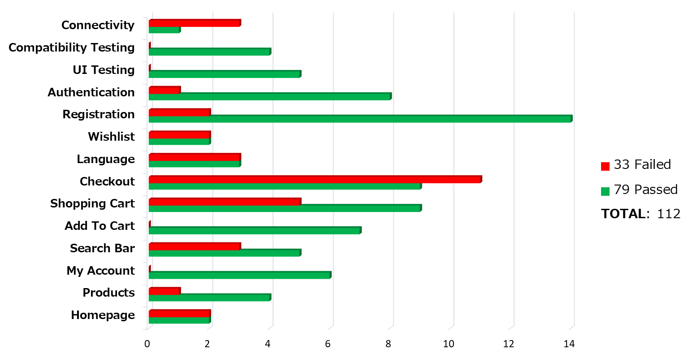

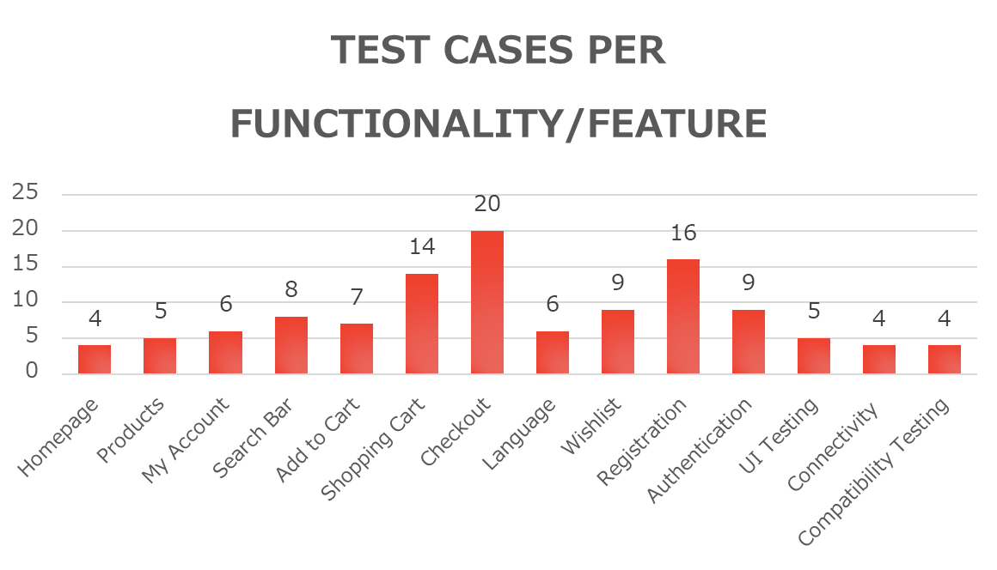

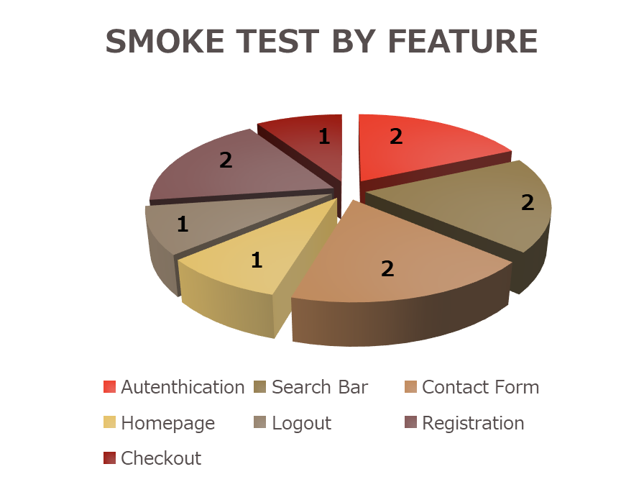

## **1.4. Exploratory Testing**

|  |  |
| --- | --- |
| Functionality | Defects |
| My Account | [0055069](https://bugs.scoalainformala.ro/view.php?id=55069), [0055070](https://bugs.scoalainformala.ro/view.php?id=55070) |
| Search Bar | [0055141](https://bugs.scoalainformala.ro/view.php?id=55141) |
| Homepage | [0055064](https://bugs.scoalainformala.ro/view.php?id=55064), [0055065](https://bugs.scoalainformala.ro/view.php?id=55065), [0055147](https://bugs.scoalainformala.ro/view.php?id=55147) |
| Add to Cart |  |
| Shopping Cart | [0055051](https://bugs.scoalainformala.ro/view.php?id=55051), [0055054](https://bugs.scoalainformala.ro/view.php?id=55054), [0055055](https://bugs.scoalainformala.ro/view.php?id=55055) |
| Checkout | [0055059](https://bugs.scoalainformala.ro/view.php?id=55059) |

# **Defects**

## **1.5. New defects**

|  |  |  |
| --- | --- | --- |
| Defect ID | Defect summary | Severity |
| [0055053](https://bugs.scoalainformala.ro/view.php?id=55053) | [Shopping Cart] Placing an order with a negative value is allowed | major |
| [0055054](https://bugs.scoalainformala.ro/view.php?id=55054) | [Shopping Cart] Adding a product to the shopping cart with quantity 0 is allowed | major |
| [0055055](https://bugs.scoalainformala.ro/view.php?id=55055) | [Shopping Cart] Adding a product to the shopping cart with big quantity data is allowed | major |
| [0055065](https://bugs.scoalainformala.ro/view.php?id=55065) | [Schimba Limba] Language functionality does not work properly | major |
| [0055069](https://bugs.scoalainformala.ro/view.php?id=55069) | [Creare Cont] An Invalid mail address is allowed when registering a new account | major |
| [0055070](https://bugs.scoalainformala.ro/view.php?id=55070) | [Creare Cont] The Password can be the same as the email address | major |
| [0055152](https://bugs.scoalainformala.ro/view.php?id=55152) | [Homepage] Some of the website's functionalities work with no internet connection | major |
| [0055051](https://bugs.scoalainformala.ro/view.php?id=55051) | [Shopping Cart] Negative values are allowed when modifying the quantity of a product | normal |
| [0055058](https://bugs.scoalainformala.ro/view.php?id=55058) | [Wishlist] Wishlist functionality is not working properly | normal |
| [0055059](https://bugs.scoalainformala.ro/view.php?id=55059) | [Checkout] Shipping fee applied when order total price is 0 | normal |
| [0055061](https://bugs.scoalainformala.ro/view.php?id=55061) | [Checkout] The currency is changed at checkout | normal |
| [0055062](https://bugs.scoalainformala.ro/view.php?id=55062) | [Checkout] The „Nume" section from „Adresa de livrare" allows big data characters inputs | normal |
| [0055063](https://bugs.scoalainformala.ro/view.php?id=55063) | [Checkout] The „Prenume" section from „Adresa de livrare" allows big data characters inputs | normal |
| [0055064](https://bugs.scoalainformala.ro/view.php?id=55064) | [Homepage] „Ai nevoie de ajutor?” feature is unavailable | normal |
| [0055060](https://bugs.scoalainformala.ro/view.php?id=55060) | [Checkout] Out of stock product is able to be added to the shopping cart | normal |
| [0055072](https://bugs.scoalainformala.ro/view.php?id=55072) | [Checkout] Finalizing order with an invalid email address ia allowed | normal |
| [0055073](https://bugs.scoalainformala.ro/view.php?id=55073) | [Checkout] Unlimited number input in the „Telefon” section is allowed | normal |
| [0055185](https://bugs.scoalainformala.ro/view.php?id=55185) | [Checkout] Non-alphabetical characters are allowed in the "Nume" and "Prenume" fields | normal |
| [0055186](https://bugs.scoalainformala.ro/view.php?id=55186) | [Checkout] Finalizing order with an invalid shipping address is allowed | normal |
| [0055071](https://bugs.scoalainformala.ro/view.php?id=55071) | [Checkout] Special characters are allowed in the „Cod Postal” section at checkout | minor |
| [0055066](https://bugs.scoalainformala.ro/view.php?id=55066) | [Search bar] Products are not available when searching by category | minor |
| [0055068](https://bugs.scoalainformala.ro/view.php?id=55068) | [Produse] Radio buttons are not working correctly | minor |
| [0055141](https://bugs.scoalainformala.ro/view.php?id=55141) | [Search bar] Search bar is allowing an empty search query | minor |
| [0055147](https://bugs.scoalainformala.ro/view.php?id=55147) | [Contact form] Invalid data is allowed when filling the contact form | minor |

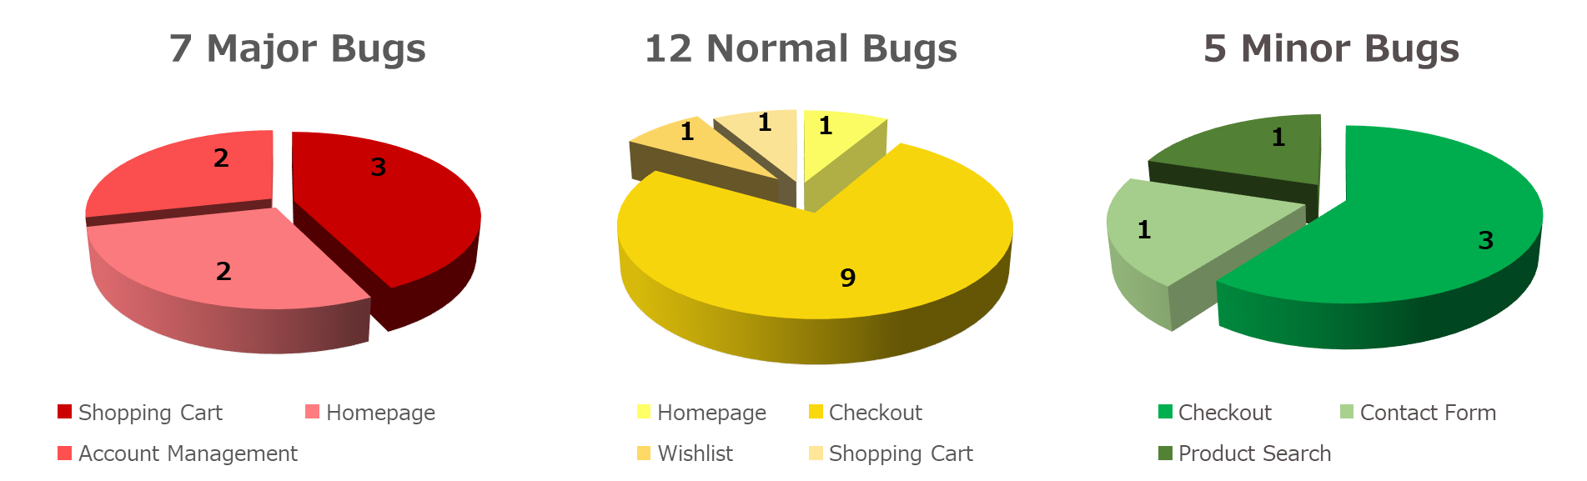

# **Conclusions**

The testing process was performed on [Adinish](https://adinish.com/) Web Application, and was divided in smoke test cases and exploratory testing. The tests were executed on:

PC, Windows 10 v22H2

Browser: Google Chrome V118.0.5993.120, Microsoft Edge 119.0.2151.44

Mobile Devices: Iphone 11, iOS 17.0.3, Samsung S20, Android

The Smoke Test Cases were structured to test the main functionalities. 112 tests out of 112 test cases were executed, a 100 percentage, from which 70.54% passed and 29.46% failed.

Exploratory testing was conducted on main functionalities. Six major bugs were identified during exploratory testing process, most of them related to the Shopping Cart feature, though other functionalities were also impacted.

From the total of 24 bugs found, 7 (29.17%) of them were major severity, 12 (50%) of them normal and 5 (20.83%) of them minor. Most of the bugs were identified by performing Negative Testing. No bugs were validated.

In addition to Smoke Test and Exploratory, testing types as: Functional Testing, Negative/Positive, Compatibility and User Interface testing were covered.

Considering the number of bugs identified, with only a small percentage of them being major, the recommendation is to fix the major bugs prior to the next release of the application. The application is ready for release, as the main purpose of this web app has been achieved and the user can take usage of it.